**Submission of Productive IPR Incentive Program Proposals**

By: **Chalid Luneto.**  October 7, 2020 11:14:55

The Deputy for Research and Development Strengthening, Directorate of Intellectual Property Management, will implement the Productive Intellectual Property Rights Incentive program in 2020. This program aims to provide incentives for individuals/institutions/business entities holding commercial IPRs and encourage increased commercialization of IPRs utilized to improve science and technology capacity, employment, strengthening and increasing the productivity of domestic industry/business activities.

The following is an important schedule related to the implementation of the program referred to above as follows:

1. Proposal Submission 1-16 October 2020
2. Online Socialization
3. Proposal Selection October 1-23, 2020
4. Award November 10, 2020

The IPR Productive Incentive proposal must be received no later than October 16, 2020, at 15.00 WIB. To upload documents, please visit http://bit.ly/insentifhkiproduktif.

Guidelines for Submission of Productive IPR Incentive Program Proposals can be accessed through the web page http://simlitabmas.ristekdikti.go.id/ or downloaded here

Attachment :

1. Circular Letter
2. Decree of IPR Incentive Guidance
3. 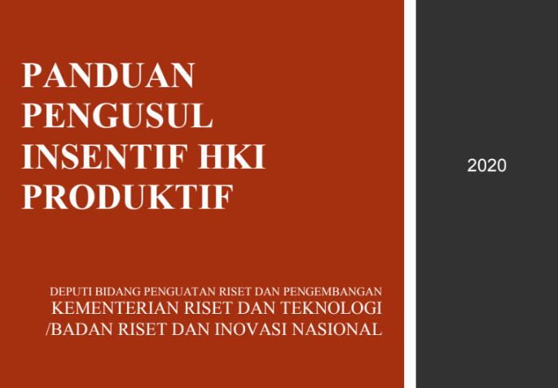IPR Incentive Guide

Source: SIMLITABMAS (07102020)